**Model Construction Procedure**

Training data preprocessing (Ruby + Matlab)

The training faces have been processed by the Face++, the attributes of the training object that we have are:

1. fid: the unique string that identify the object
2. name: the name of the image
3. url: the path to the image
4. img_width: the width of the image (used to calculate the relative position of the facial landmark points)
5. img_height: similar to 4
6. landmark: the 25 points describes the major facial landmarks

An example of the training object attributes is:

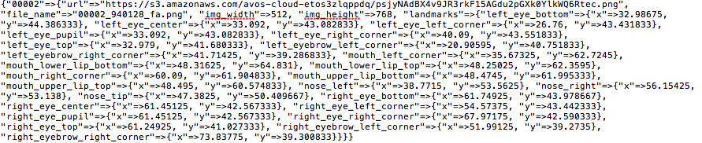

There are totally 964 training objects, and in order to increase the accuracy of the model later we will build, we mirror the images into 4 other directions to gain more training samples. Therefore, after the mirroring, we will have 3856 (964 x 4) training objects. In other words, we will have 3856 facial images to process.

For each given face, we will look at its 4 primary interest areas for 8 variables, they are:

1. skins under two eyes -> dark circle, eye bag
2. two eyes -> hanging eyelid, glazed eye, swollen eye, red eye
3. skin on check -> pale skin
4. mouth -> droopy mouth corner

note: the size of cropped eye area may vary for different variables.

The illustration is as follow:

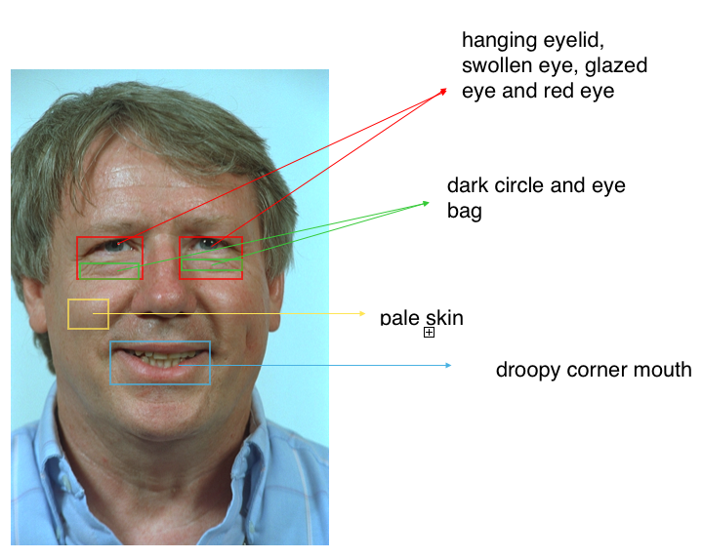

Each box will return a sub-image and we will use dense sift to as the feature extractor. Note that the smaller size the sub-image, the short the processing time is needed.

The feature vectors, which are for variables other than droopy corner mouth and pale skin, are a concatenation of the features of the two paired boxes. So, for each face, after cropping and applying dense sift, we would obtain 8 feature vectors, each one of them will be used to build a corresponding model.

Model building (Matlab)

Since there are 8 variables in total, we will need to build 8 regression SVM models, and for each variable model, we will have 3856 feature vectors to train it. The process can be illustrated as below:

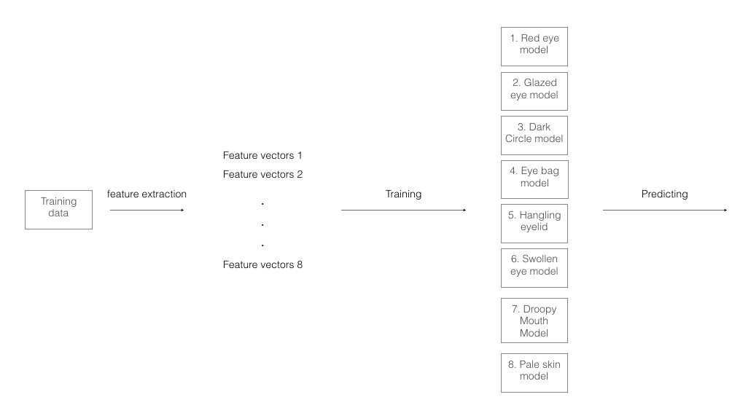

**Prediction Procedure**

Similar as how we have processed the training face before, we extract eight feature vectors from each predicting face, and give each of them to the pertained model to obtain a related score. After we obtained eight different scores from eight different models, we apply those scores to *f*, which is the regression model that we derived from the medical paper, and calculate out the final fatigue score for each face.